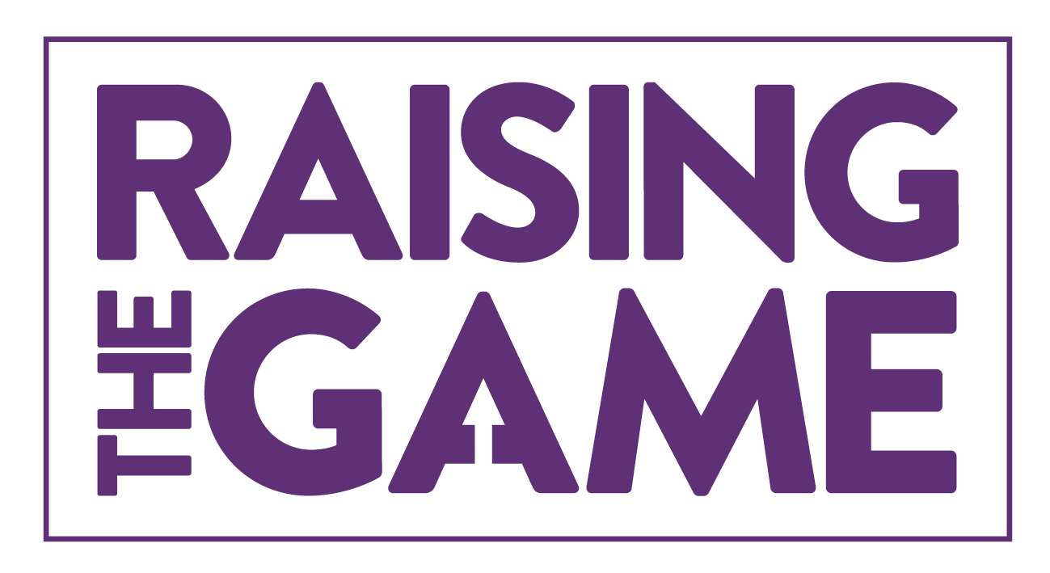
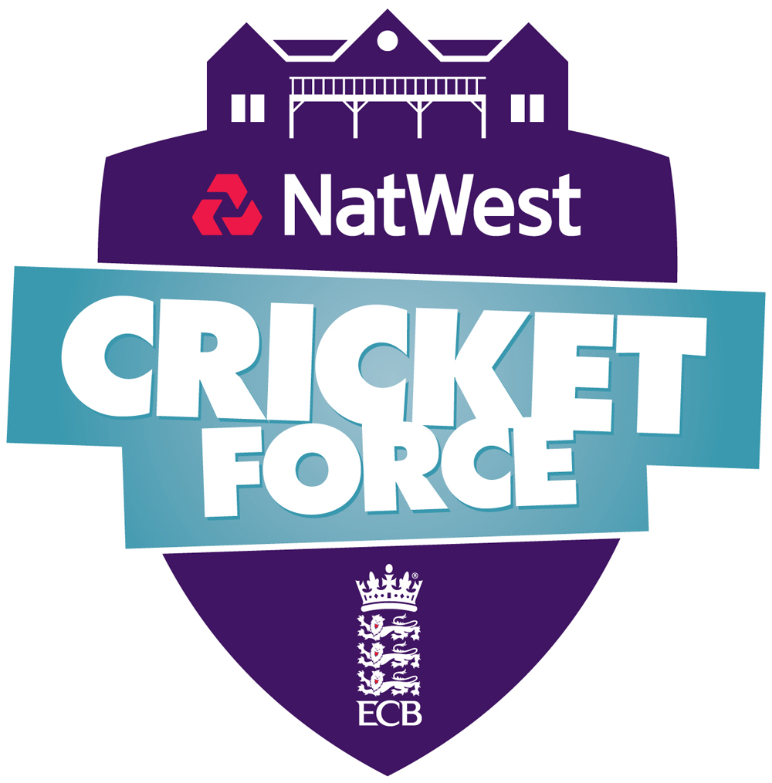
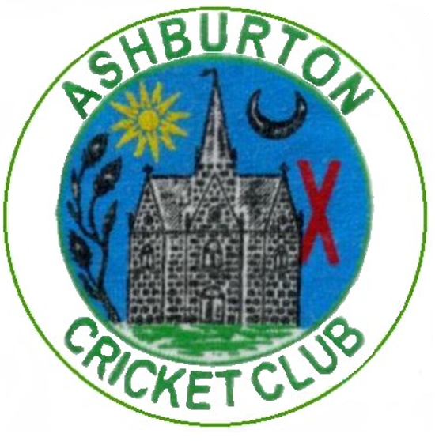
ASHBURTON CRICKET CLUB

Varwell Field, Balland Lane, TQ13 7BP
1889-1973, Reformed 1978
President – Fred Christophers Esq
Chairman – Chris Yeo

JUNIOR MEMBERSHIP Form 2023
Outdoor training sessions (10-15yr olds) are led by qualified coaches with help from volunteers and run from 6pm-7pm on Friday evenings from May to Aug.
Youth cricket costs £35/season and can ONLY be paid via BACS.
ASHBURTON CRICKET CLUB - Sort code 54-10-39 - Account number 15914194 - (NatWest Account)
Please add your child’s name and the word "Member" as the reference
PERSONAL DETAILS (PARENT & CHILD)
Childs Name: | Gender:
Address (including postcode):

Parents Full Name:
Home telephone number: | Parent mobile number:
Parents Email address:
Date of birth: | School & school year:
I give consent to be contacted by
telephone (text/call/whatsapp group) email (match information / club newsletters)

The club has adopted the ECB’s “Safe Hands – Welfare of Young People in Cricket” Policy, so please complete these consent forms
MEDICAL INFORMATION
Family doctor and surgery name:
Telephone number:
Does your child have any disability (eg visual, hearing impairment, learning, physical, multiple or other disability), medical conditions or allergies (e.g. epilepsy, asthma, diabetes etc) or take any medication we should be aware of? Yes/No
If yes, please give details:
Emergency contact name: | Emergency contact number:
Relationship: | Date of last tetanus vaccination if known:
Medical consent:
I give my consent that in an emergency situation, the Club may act in loco parentis, if the need arises for the administration of emergency first aid and / or other medical treatment which in the opinion of a qualified medical practitioner may be necessary. I also understand that in such an occurrence that all reasonable steps will be taken to contact me or the alternative adult whom I have named in this form.
I confirm that to the best of my knowledge, my child does not suffer from any medical condition or disability other than those detailed by me in this section of the form.

Safeguarding & Policies: There are a number of policies that have been adopted to safeguard children and these are both displayed on our website and the club’s notice board.
I confirm I have been made aware of, and/or read the following adopted policy sections (available on the Ashburton website, at club in the ‘Policy Folder’ or by contacting the Welfare Officer). These include :
- Changing / Showering - Missing children
- Transport - Anti-Bullying Policy
- Photography / Video - Safeguarding Policy Statement
- ECB Youth Directives - Code of Conduct (Parents & Colts)
I understand and agree to the responsibilities which I and my child have in connection with these policies
I consent to the Club photographing or videoing my child’s involvement in cricket under the terms and conditions in the Club photography / video policy. (Used on the club website, press releases, match reports, etc.)
[NOTE: THIS BOX SHOULD BE LEFT UNTICKED IF YOU DO NOT AGREE]
By returning this completed form, I agree to my son/daughter/child in my care taking part in the activities of the club.
I understand that in the event of any injury or illness all reasonable steps will be taken to contact me, and to deal with that injury/illness appropriately

Membership Fees. Youth cricket costs £35/season
Volunteer? The junior section is keen to involve parents/guardians in every aspect of what we offer, if you have a little spare time and would like to help out please tick the box below and a member of our committee will speak to you.
Yes I would like to help
Data Protection. The Club will use the information provided on this form (together with other information it obtains about the player) (together “Information”) to administer his/ her cricketing activity at the Club and in any activities in which he participates through the Club and to care for and supervise activities in which he/she is involved. In some cases this may require the Club to disclose the Information to County Boards, Leagues and to the England and Wales Cricket Board. In the event of a medical issue or child protection issue arising, the Club may disclose certain information to doctors or other medical specialists and/or to police, children’s social care, the Courts and/or probation officers and, potentially to legal and other advisers involved in an investigation.
As the person completing this form, you must ensure that each person whose information you include in this form knows what will happen to their information and how it may be disclosed
Signed (Parent / Legal Guardian): | Date of signing:
Printed name of Parent / Legal Guardian who has completed this form:
Ashburton Cricket Club comply with the new GDPR legislation that came into effect from 25th May 2018.

Child Sporting Information (optional)
Have you played cricket before? |  | Yes |  | No
If yes, where have you played cricket:
Primary school |  | Secondary school |  | Local authority coaching session(s)
Club |  | County |  | Other(please specify):

Parent Sporting Information (optional)
Have you played cricket before? |  | Yes |  | No
If yes, where have you played cricket:
Primary school |  | Secondary school |  | Local authority coaching session(s)
Club |  | County |  | Other(please specify):

