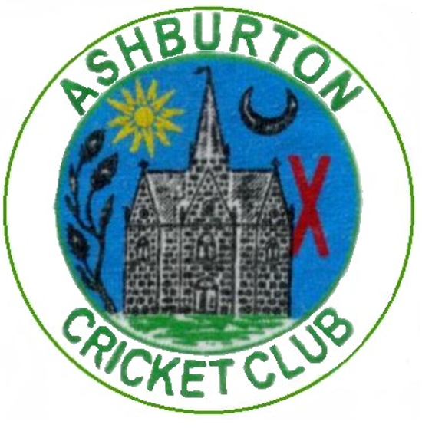
ASHBURTON CRICKET CLUB

Varwell Field, Balland Lane, TQ13 7BP
1889-1973, Reformed 1978
President – Fred Christophers Esq
Chairman – Chris Yeo

Dear colts members, parents, coaches and volunteers!

Welcome to Varwell Field! We are delighted to be back for the 2023 season and to be hosting Allstars and Dynamos as well as ensuring opportunities, coaching and games for all players aged between 11 and 16.

Sessions start on Friday 28th April which will be our first training session and an opportunity to get the signing up paperwork all sorted. Training sessions will run from 6-7pm every Friday from this date throughout the season. Please note that for Dynamos and Allstars the first session will be Friday 12th May and sessions will run for 8 weeks.

We will be having a Bar-B-Q on the 28th with burgers and hotdogs available for a small charge. We want to make this season an enjoyable one for all the families involved and to this end we will be ensuring that every Friday evening while training is on, we will have the club bar open and ensure that hot and cold drinks are available.

We have a few games already arranged and we will provide the fixtures list on the 28th. Our focus is allowing the players to enjoy playing cricket and to develop at their own pace and in a safe and happy environment regardless of experience and ability, all games will be designed to support with this.

We are always very keen to encourage parental support and involvement and if you would like to help out or get involved in any way do, please mention to a member of the club coaches who will happily support with this. It doesn’t have to be a regular commitment, but many hands help.

Membership Payments.
The only payment that the cricket club asks of you, is a £35 membership fee. (If you have signed your child up for the Allstars or Dynamos programmes via the ECB website you do not need to pay this, please see below.) This covers your child’s membership for the 2023 season, along with covering the parent or guardian’s membership. This payment covers all training and any match fees. Equipment is provided by the club, so do not worry if your child does not have a bat, pads, helmet, and gloves. The only equipment the club does not provide is a box. These can be purchased online or at any sports store quite cheaply, but they are a vital piece of equipment for all hard ball cricket games and practise.

Payment can be made online to details:
Ashburton Cricket Club
Sort code 54-10-39
Account number 15914194 - (NatWest Account)
Please enter your child’s name as reference.

Allstar and Dynamo Membership payments.
We run both AllStars and Dynamos programmes at Ashburton and the payment of £40 here is paid directly to the England Cricket Board. By paying this, direct to them, your child will receive a welcome and equipment pack directly from the ECB. This payment is instead of the club membership outlined above but will provide membership to the club for player and parents.

We are pleased to be able to offer youth section training/playing tops for all our players this season. Thanks to generous sponsorship from ‘Celtic Rock Services’ shirts can be purchased through the club and once membership has been paid we can offer a 50% discount, making the shirts £7 (Juniors) or £8 (Adult sizes). For further details please speak to me or to any of the team managers. Alternatively, shirts and other kit can be purchased at full price through the Devon County Sports website below.

Club clothing can be purchased from the Devon County Sports shop, found online or at Paignton - https://www.devoncountysports.com/Club-Shop/Ashburton-CC-Clothing (298 Torquay Road, Paignton, Devon. TQ3 2ER)

Key Contacts
Marcus West (Youth Cricket Co-ordinator & Dynamos Activator) – 07478 657280
marcuswest303@gmail.com

Vernon Coon (Club Safeguarding Officer) – 07746 876956
vernon.coon@btinternet.com

Andrew Hayman (U15s Manager) - 07724 451730

Will Vevers (U13s Manager) - 07484 685864

Greg Robinson (U13s Manager) - 07756982416

Sarah Wood (Allstars Activator) - 07870 249391

Lloyd White (Club Secretary) – 07931 895123
lloydwhite92@hotmail.com

May I take this opportunity to thank all those parents, volunteers and coaches who give up their time to be involved with our exciting colts section. Without your help by driving to games, assisting with training, officiating, assisting with registration and more it would all be a lot more complicated!

If in the meantime you have any questions, please do not hesitate to get in touch.
We look forward to seeing you all very soon,

Marcus

Marcus West
Youth Cricket Co-ordinator

